Mentor Full Sample Report
OEQA Mentor/Administrator Survey 2022
June 21st 2022, 7:17 am CDT
1. The person completing this survey is:
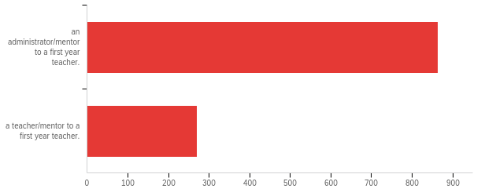

# | Answer | % | Count
1 | an administrator/mentor to a first year teacher. | 76.19% | 864
2 | a teacher/mentor to a first year teacher. | 23.81% | 270
 | Total | 100% | 1134

2. The Learner and Learning Please rate the extent to which you agree that each statement is true of [ExternalDataReference].
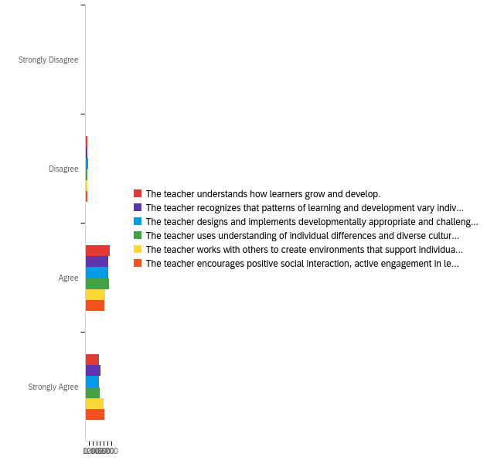

# | Question | Strongly Disagree |  | Disagree |  | Agree |  | Strongly Agree |  | Total
1 | The teacher understands how learners grow and develop. | 0.72% | 8 | 4.43% | 49 | 60.43% | 669 | 34.42% | 381 | 1107
2 | The teacher recognizes that patterns of learning and development vary individually within and across the cognitive, linguistic, social, emotional, and physical areas. | 1.26% | 14 | 5.24% | 58 | 56.91% | 630 | 36.59% | 405 | 1107
3 | The teacher designs and implements developmentally appropriate and challenging learning experiences. | 1.81% | 20 | 7.50% | 83 | 56.46% | 625 | 34.24% | 379 | 1107
4 | The teacher uses understanding of individual differences and diverse cultures and communities to ensure inclusive learning environments that enable each learner to meet high standards. | 1.26% | 14 | 5.69% | 63 | 57.99% | 642 | 35.05% | 388 | 1107
5 | The teacher works with others to create environments that support individual and collaborative learning. | 1.26% | 14 | 5.15% | 57 | 48.06% | 532 | 45.53% | 504 | 1107
6 | The teacher encourages positive social interaction, active engagement in learning, and self-motivation. | 0.99% | 11 | 4.16% | 46 | 47.43% | 525 | 47.43% | 525 | 1107

3. Content Please rate the extent to which you agree that each statement is true of [ExternalDataReference].
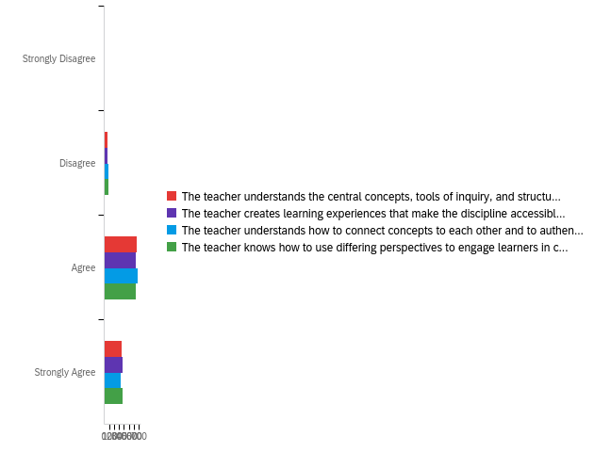

# | Question | Strongly Disagree |  | Disagree |  | Agree |  | Strongly Agree |  | Total
1 | The teacher understands the central concepts, tools of inquiry, and structures of the discipline(s) he or she teaches. | 1.00% | 11 | 5.64% | 62 | 60.73% | 668 | 32.64% | 359 | 1100
2 | The teacher creates learning experiences that make the discipline accessible and meaningful for learners to assure mastery of the content. | 1.36% | 15 | 6.36% | 70 | 58.36% | 642 | 33.91% | 373 | 1100
3 | The teacher understands how to connect concepts to each other and to authentic local and global issues. | 1.00% | 11 | 7.46% | 82 | 61.24% | 673 | 30.30% | 333 | 1099
4 | The teacher knows how to use differing perspectives to engage learners in critical thinking, creativity, and collaborative problem solving. | 1.18% | 13 | 7.82% | 86 | 57.91% | 637 | 33.09% | 364 | 1100

4. Instructional Practice Please rate the extent to which you agree that each statement is true of [ExternalDataReference].
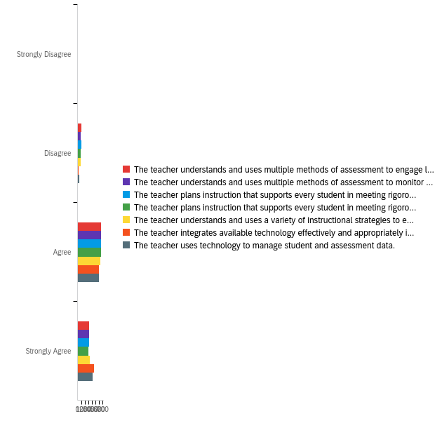

# | Question | Strongly Disagree |  | Disagree |  | Agree |  | Strongly Agree |  | Total
1 | The teacher understands and uses multiple methods of assessment to engage learners in their own growth and guide learners' decision making. | 0.92% | 10 | 9.17% | 100 | 59.91% | 653 | 30.00% | 327 | 1090
2 | The teacher understands and uses multiple methods of assessment to monitor learner progress and to guide his/her decision making. | 1.01% | 11 | 8.72% | 95 | 59.72% | 651 | 30.55% | 333 | 1090
3 | The teacher plans instruction that supports every student in meeting rigorous learning goals by drawing upon knowledge of content areas, curriculum, cross-disciplinary skills, and pedagogy. | 1.38% | 15 | 9.17% | 100 | 59.72% | 651 | 29.72% | 324 | 1090
4 | The teacher plans instruction that supports every student in meeting rigorous learning goals by drawing upon knowledge of learners and the community context. | 1.28% | 14 | 8.99% | 98 | 61.01% | 665 | 28.72% | 313 | 1090
5 | The teacher understands and uses a variety of instructional strategies to encourage learners to develop deep understanding of content areas and their connections, and to build skills to apply knowledge in meaningful ways. | 1.28% | 14 | 8.26% | 90 | 58.35% | 636 | 32.11% | 350 | 1090
6 | The teacher integrates available technology effectively and appropriately into instruction. | 0.46% | 5 | 2.94% | 32 | 54.87% | 597 | 41.73% | 454 | 1088
7 | The teacher uses technology to manage student and assessment data. | 0.46% | 5 | 5.14% | 56 | 54.77% | 597 | 39.63% | 432 | 1090

5. Professional Responsibility Please rate the extent to which you agree that each statement is true of [ExternalDataReference].
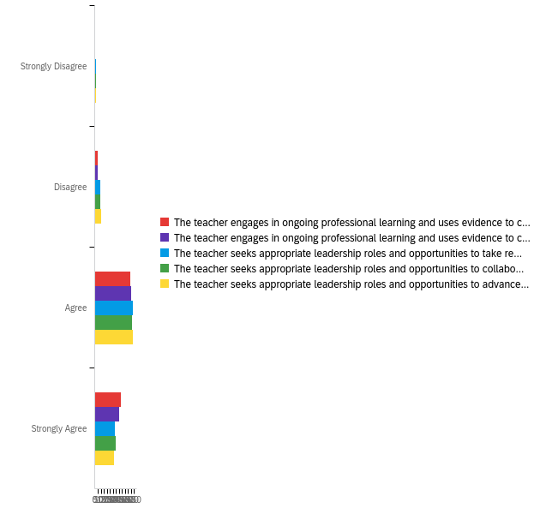

# | Question | Strongly Disagree |  | Disagree |  | Agree |  | Strongly Agree |  | Total
1 | The teacher engages in ongoing professional learning and uses evidence to continually evaluate his/her practice, particularly the effects of his/her choices and actions on others (learners, families, other professionals, and the community). | 0.92% | 10 | 4.43% | 48 | 55.03% | 596 | 39.61% | 429 | 1083
2 | The teacher engages in ongoing professional learning and uses evidence to continually adapt practice to meet the needs of each learner. | 0.83% | 9 | 5.08% | 55 | 56.23% | 609 | 37.86% | 410 | 1083
3 | The teacher seeks appropriate leadership roles and opportunities to take responsibility for student learning. | 1.39% | 15 | 8.96% | 97 | 58.45% | 633 | 31.21% | 338 | 1083
4 | The teacher seeks appropriate leadership roles and opportunities to collaborate with learners, families, colleagues, other school professionals, and community members to ensure learner growth. | 1.39% | 15 | 8.96% | 97 | 57.53% | 623 | 32.13% | 348 | 1083
5 | The teacher seeks appropriate leadership roles and opportunities to advance the profession. | 1.66% | 18 | 10.06% | 109 | 58.73% | 636 | 29.55% | 320 | 1083

6. Overall, [ExternalDataReference]'s preparation/route to certification effectively prepared him/her to have a positive impact on P12 student learning and development.
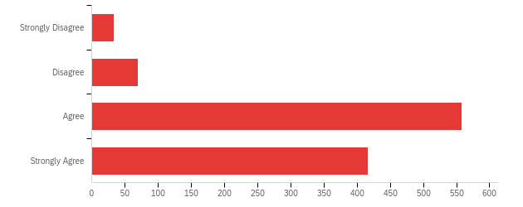

# | Answer | % | Count
1 | Strongly Disagree | 3.07% | 33
2 | Disagree | 6.41% | 69
3 | Agree | 51.86% | 558
4 | Strongly Agree | 38.66% | 416
 | Total | 100% | 1076

Q8 - Considering [ExternalDataReference]'s preparation in light of the needs of your school, what are your recommendations for strengthening the teacher's preparation?
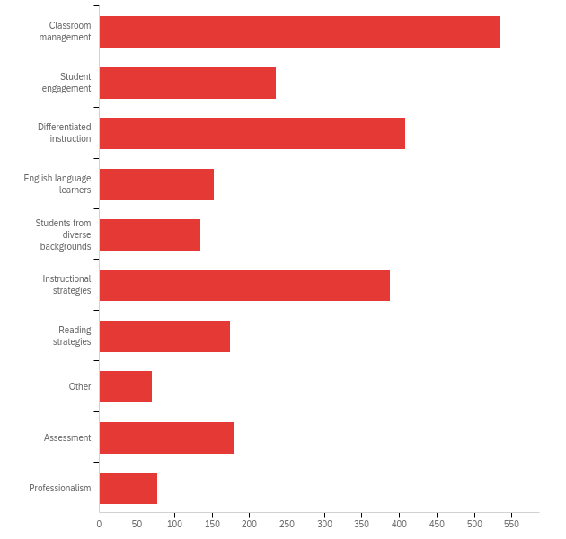

# | Answer | % | Count
1 | Classroom management | 22.68% | 534
2 | Student engagement | 10.02% | 236
3 | Differentiated instruction | 17.32% | 408
4 | English language learners | 6.50% | 153
5 | Students from diverse backgrounds | 5.73% | 135
6 | Instructional strategies | 16.48% | 388
7 | Reading strategies | 7.43% | 175
8 | Other | 2.97% | 70
9 | Assessment | 7.60% | 179
10 | Professionalism | 3.27% | 77
 | Total | 100% | 2355

8. [ExternalDataReference] received his/her degree at which of the following institutions? If the teacher has an alternative or emergency certificate, please select Oklahoma State Department of Education.
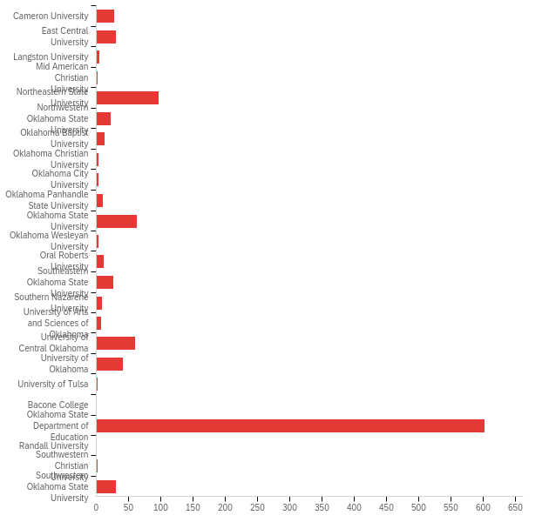

# | Answer | % | Count
1 | Cameron University | 2.61% | 28
2 | East Central University | 2.79% | 30
3 | Langston University | 0.47% | 5
4 | Mid American Christian University | 0.19% | 2
6 | Northeastern State University | 9.03% | 97
7 | Northwestern Oklahoma State University | 2.05% | 22
8 | Oklahoma Baptist University | 1.21% | 13
9 | Oklahoma Christian University | 0.28% | 3
10 | Oklahoma City University | 0.37% | 4
11 | Oklahoma Panhandle State University | 0.93% | 10
12 | Oklahoma State University | 5.87% | 63
13 | Oklahoma Wesleyan University | 0.37% | 4
14 | Oral Roberts University | 1.02% | 11
15 | Southeastern Oklahoma State University | 2.42% | 26
16 | Southern Nazarene University | 0.84% | 9
17 | University of Arts and Sciences of Oklahoma | 0.74% | 8
18 | University of Central Oklahoma | 5.59% | 60
19 | University of Oklahoma | 3.82% | 41
20 | University of Tulsa | 0.19% | 2
21 | Bacone College | 0.00% | 0
22 | Oklahoma State Department of Education | 56.05% | 602
23 | Randall University | 0.09% | 1
24 | Southwestern Christian University | 0.19% | 2
25 | Southwestern Oklahoma State University | 2.89% | 31
 | Total | 100% | 1074

9. [ExternalDataReference] received his/her license via:
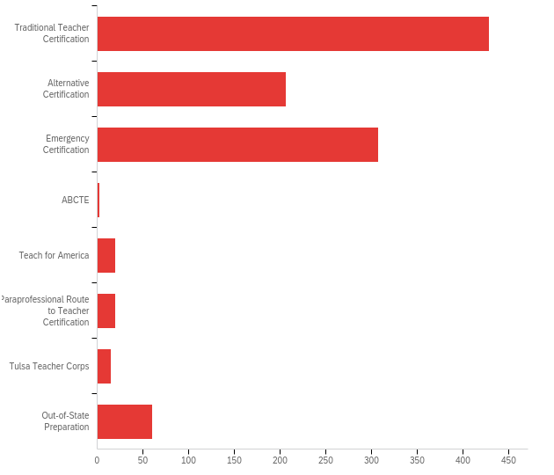

# | Answer | % | Count
1 | Traditional Teacher Certification | 40.43% | 429
2 | Alternative Certification | 19.51% | 207
3 | Emergency Certification | 29.03% | 308
4 | ABCTE | 0.19% | 2
5 | Teach for America | 1.89% | 20
6 | Paraprofessional Route to Teacher Certification | 1.89% | 20
7 | Tulsa Teacher Corps | 1.41% | 15
8 | Out-of-State Preparation | 5.66% | 60
 | Total | 100% | 1061

10. In what area was [ExternalDataReference] initially certified? (Please check all that apply)
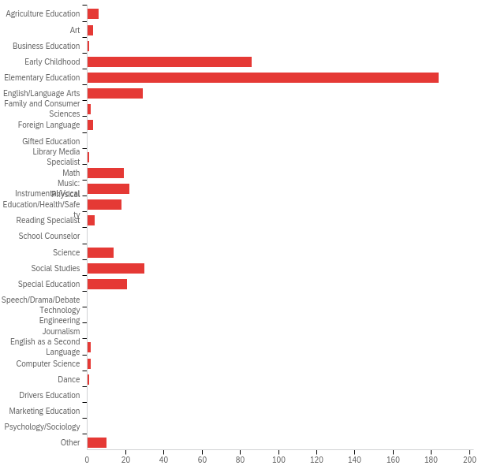

# | Answer | % | Count
1 | Agriculture Education | 1.31% | 6
2 | Art | 0.66% | 3
3 | Business Education | 0.22% | 1
4 | Early Childhood | 18.78% | 86
5 | Elementary Education | 40.17% | 184
6 | English/Language Arts | 6.33% | 29
7 | Family and Consumer Sciences | 0.44% | 2
8 | Foreign Language | 0.66% | 3
9 | Gifted Education | 0.00% | 0
10 | Library Media Specialist | 0.22% | 1
11 | Math | 4.15% | 19
12 | Music: Instrumental/Vocal | 4.80% | 22
13 | Physical Education/Health/Safety | 3.93% | 18
14 | Reading Specialist | 0.87% | 4
15 | School Counselor | 0.00% | 0
16 | Science | 3.06% | 14
17 | Social Studies | 6.55% | 30
18 | Special Education | 4.59% | 21
19 | Speech/Drama/Debate | 0.00% | 0
20 | Technology Engineering | 0.00% | 0
21 | Journalism | 0.00% | 0
22 | English as a Second Language | 0.44% | 2
23 | Computer Science | 0.44% | 2
24 | Dance | 0.22% | 1
25 | Drivers Education | 0.00% | 0
26 | Marketing Education | 0.00% | 0
27 | Psychology/Sociology | 0.00% | 0
35 | Other | 2.18% | 10
 | Total | 100% | 458

11. What is [ExternalDataReference]'s primary teaching assignment? (Please check all that apply)
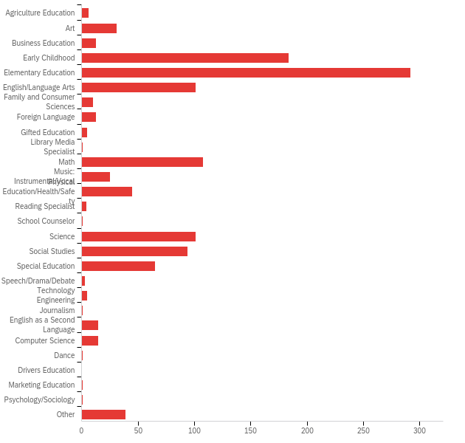

# | Answer | % | Count
1 | Agriculture Education | 0.51% | 6
2 | Art | 2.63% | 31
3 | Business Education | 1.10% | 13
4 | Early Childhood | 15.59% | 184
5 | Elementary Education | 24.75% | 292
6 | English/Language Arts | 8.56% | 101
7 | Family and Consumer Sciences | 0.85% | 10
8 | Foreign Language | 1.10% | 13
9 | Gifted Education | 0.42% | 5
10 | Library Media Specialist | 0.08% | 1
11 | Math | 9.15% | 108
12 | Music: Instrumental/Vocal | 2.12% | 25
13 | Physical Education/Health/Safety | 3.81% | 45
14 | Reading Specialist | 0.34% | 4
15 | School Counselor | 0.08% | 1
16 | Science | 8.56% | 101
17 | Social Studies | 7.97% | 94
18 | Special Education | 5.51% | 65
19 | Speech/Drama/Debate | 0.25% | 3
20 | Technology Engineering | 0.42% | 5
21 | Journalism | 0.08% | 1
22 | English as a Second Language | 1.27% | 15
23 | Computer Science | 1.27% | 15
24 | Dance | 0.08% | 1
25 | Drivers Education | 0.00% | 0
26 | Marketing Education | 0.08% | 1
27 | Psychology/Sociology | 0.08% | 1
35 | Other | 3.31% | 39
 | Total | 100% | 1180

